More water
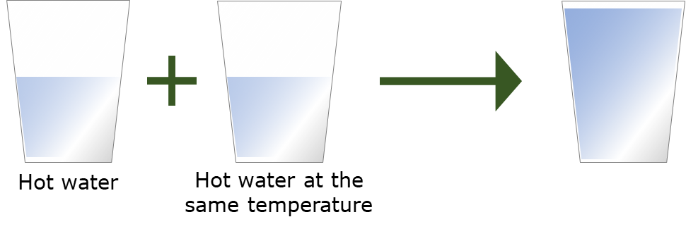
1.

What will the water feel like when it is mixed?
Put a tick (✓) in the box next to the best answer.

A | Hotter
B | The same temperature
C | Colder

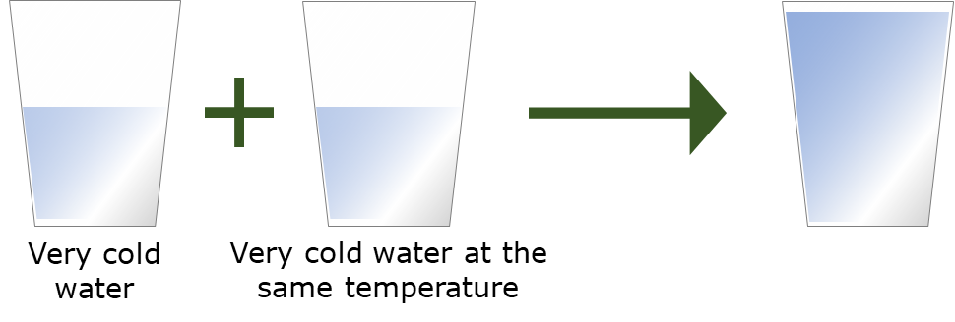
2.

What will the water feel like when it is mixed?
Put a tick (✓) in the box next to the best answer.

A | Hotter
B | The same temperature
C | Colder

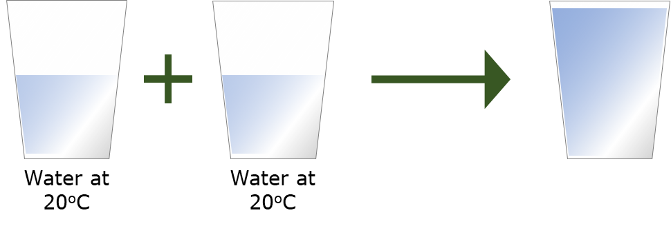
3.

What temperature will the water be when it is mixed?
Put a tick (✓) in the box next to the best answer.

A | 40ºC
B | 20 ºC
C | 0ºC

Physics > Big idea PMA: Matter > Topic PMA1: Heating and cooling > Key concept PMA1.1: Temperature
Diagnostic question
More water

Overview
Learning focus: | Temperature is a measure of the average speed at which the particles in a substance or material are moving
Observable learning outcome: | Predict the temperature reached by mixing samples of water that are all at the same temperature
Question type: | Simple multiple choice
Key words: | Temperature

P | PRIOR UNDERSTANDING  This diagnostic question probes understanding of ideas that are usually taught at age 5-11, to aid transition from earlier stages of learning.

What does the research say?
It is important for students to understand that temperature is an indication of the concentration of energy in an object. A material that is in thermal equilibrium with a room contains energy in its thermal store in proportion to its mass, but its temperature will be the same no matter what that mass is. In a study of 8- to 14-year-olds (n=324) it was found that one in six 13- to 14-year-olds, and half of 12-year-olds thought that larger ice-cubes were colder than smaller ones because they take longer to melt (Driver and Russell, 1982).
Students are usually good at predicting that when samples of hot and cold water are mixed, the temperature of the mixture is somewhere in the middle. When samples are mixed that are both at the same temperature, they need to use the idea that temperature is an intensive property in order to predict that the resulting temperature is no different. Some students are likely to get this wrong because they confuse temperature with an amount of energy and adding more water adds more energy. When a value for the temperature of each sample is given some students add or subtract the temperatures, applying a mathematical process without appearing to think about what happens. (Erickson and Tiberghien, 1985; Driver et al., 1994; Millar, 2011)
Ways to use this question
Students should complete the question individually. This could be a pencil and paper exercise, or you could use an electronic ‘voting system’ or mini white boards and the PowerPoint presentation.
The answers to the question will show you whether students understood the concept sufficiently well to apply it correctly.
If there is a range of answers, you may choose to respond through structured class discussion. Ask one student to explain why they gave the answer they did; ask another student to explain why they agree with them; ask another to explain why they disagree, and so on. This sort of discussion gives students the opportunity to explore their thinking and for you to really understand their learning needs.
Differentiation
You may choose to read the questions to the class, so that everyone can focus on the science. In some situations it may be more appropriate for a teaching assistant to read for one or two students.
Equipment
For the class:

- x3 250 cm³ beakers
- x3 thermometer (0-100ºC)
- kettle
- access to very cold water

Expected answers
1: B, 2: B, 3: B
How to respond - what next?
For those who understand temperature it should be obvious that the temperature in each case will be constant throughout.
Often students confuse temperature with an amount of energy and adding more water adds more energy. In question 1 these students may predict the combined sample is hotter.
Sometimes students think of ‘heat’ and ‘cold’ as ‘substances’ that can be held by materials. In question 2 this idea can lead students to predict the combined sample is colder.
When numbers are added some students add or subtract the temperatures, applying a mathematical process without appearing to think about what happens. Answers A and C are obtained by adding or subtracting the temperatures.
If students have misunderstandings about combining water samples of equal temperatures, it can help to demonstrate what happens in the classroom. Demonstrating the reverse process of splitting a larger sample into two smaller volumes may make it more obvious to students that the temperature of all samples is the same. This can lead into a discussion about how temperature is an intensive property, and not an extensive property that is additive and increases with more mass. This means that temperature is a local physical property, rather like the colour of modelling clay that can be observed with any small sample of the clay. In this sense coloured modelling clay could perhaps be used to illustrate this.
Acknowledgments
Developed by Peter Fairhurst (UYSEG), from an idea by Erickson and Tiberghien (1985)
Images: Peter Fairhurst (UYSEG).
References
Driver, R. and Russell, T. (1982). An investigation of the ideas of heat, temperature and change of state of children aged between 8 and 14 years. Leeds: University of Leeds.
Driver, R., et al. (1994). Making Sense of Secondary Science: Research into Children's Ideas, London, UK: Routledge.
Erickson, G. and Tiberghien, A. (1985). Heat and Temperature. In Driver, R., Guesne, E. & Tiberghien, A. (eds.) Children's Idease In Science. Milton Keynes and Philadelphia: Open University Press.
Millar, R. (2011). Energy. In Sang, D. (ed.) Teaching Secondary Physics. London: Hodder Education.

